**Assignment**

**CSA0805 – Python Programming**

|  |  |
| --- | --- |
| **Register Number** | **192324267** |
| **Name** | **VEDVYASS M** |

**Title: File System Watcher**

**Problem Statement:** Design a Python program that monitors a directory for changes, such as file creations, deletions, or modifications, and logs these events in real-time, optionally triggering actions based on predefined rules

**Code:**

**import os**

**import time**

**import hashlib**

**import logging**

**# Configure logging**

**logging.basicConfig(level=logging.INFO, format='%(asctime)s - %(message)s', datefmt='%Y-%m-%d %H:%M:%S')**

**logger = logging.getLogger(__name__)**

**def get_file_hash(file_path):**

**"""Calculate the MD5 hash of a file."""**

**md5_hash = hashlib.md5()**

**with open(file_path, 'rb') as f:**

**for chunk in iter(lambda: f.read(4096), b""):**

**md5_hash.update(chunk)**

**return md5_hash.hexdigest()**

**def scan_directory(directory):**

**"""Scan a directory and return a dictionary of file paths and their hashes."""**

**file_hashes = {}**

**for root, dirs, files in os.walk(directory):**

**for file_name in files:**

**file_path = os.path.join(root, file_name)**

**file_hashes[file_path] = get_file_hash(file_path)**

**return file_hashes**

**def monitor_directory(directory, rules=None, interval=1):**

**"""Monitor the directory for changes."""**

**previous_scan = scan_directory(directory)**

**logger.info(f"Starting directory monitoring on: {directory}")**

**try:**

**while True:**

**time.sleep(interval)**

**current_scan = scan_directory(directory)**

**# Check for created or modified files**

**for file_path, file_hash in current_scan.items():**

**if file_path not in previous_scan:**

**logger.info(f"File created: {file_path}")**

**apply_rules(file_path, 'created', rules)**

**elif previous_scan[file_path] != file_hash:**

**logger.info(f"File modified: {file_path}")**

**apply_rules(file_path, 'modified', rules)**

**# Check for deleted files**

**for file_path in previous_scan.keys():**

**if file_path not in current_scan:**

**logger.info(f"File deleted: {file_path}")**

**apply_rules(file_path, 'deleted', rules)**

**previous_scan = current_scan**

**except KeyboardInterrupt:**

**logger.info("Directory monitoring stopped.")**

**def apply_rules(file_path, event_type, rules):**

**"""Apply predefined rules based on file events."""**

**if rules:**

**for rule in rules:**

**if rule['event_type'] == event_type and rule['condition'](file_path):**

**rule['action'](file_path)**

**def custom_action(file_path):**

**"""Example action to take when a rule is triggered."""**

**logger.info(f"Custom action triggered for {file_path}")**

**if __name__ == "__main__":**

**# Replace with the directory you want to monitor**

**path_to_monitor = "/path/to/monitor"**

**# Define rules for triggering actions**

**rules = [**

**{**

**'event_type': 'created',**

**'condition': lambda path: path.endswith('.txt'), # Trigger only if a .txt file is created**

**'action': custom_action**

**},**

**{**

**'event_type': 'modified',**

**'condition': lambda path: 'important' in path, # Trigger if 'important' is in the file path**

**'action': custom_action**

**},**

**{**

**'event_type': 'deleted',**

**'condition': lambda path: True, # Trigger on any file deletion**

**'action': custom_action**

**}**

**]**

**# Start monitoring the directory**

**monitor_directory(path_to_monitor, rules=rules, interval=2)**

**Output Screen Shots:**

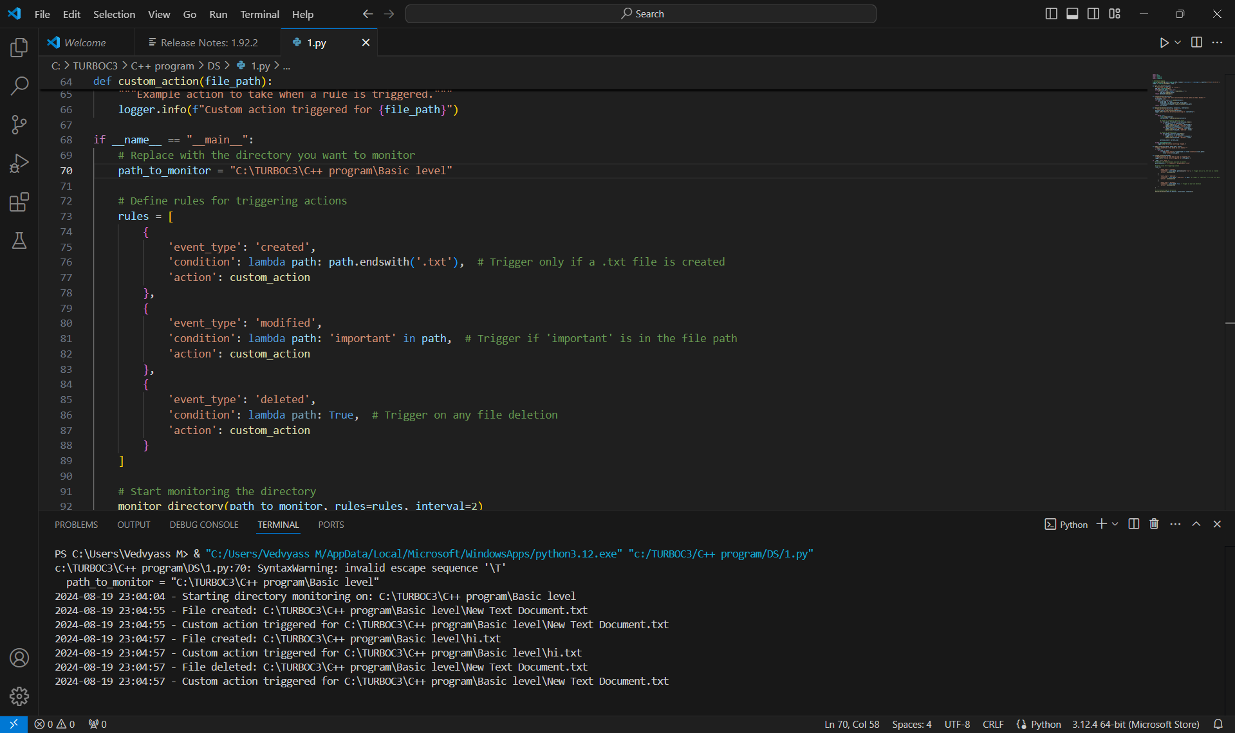

**Conclusion:**

Python program that monitors a directory for changes, such as file creations, deletions, or modifications, and logs these events in real-time, optionally triggering actions based on predefined rules is successfully created and executed